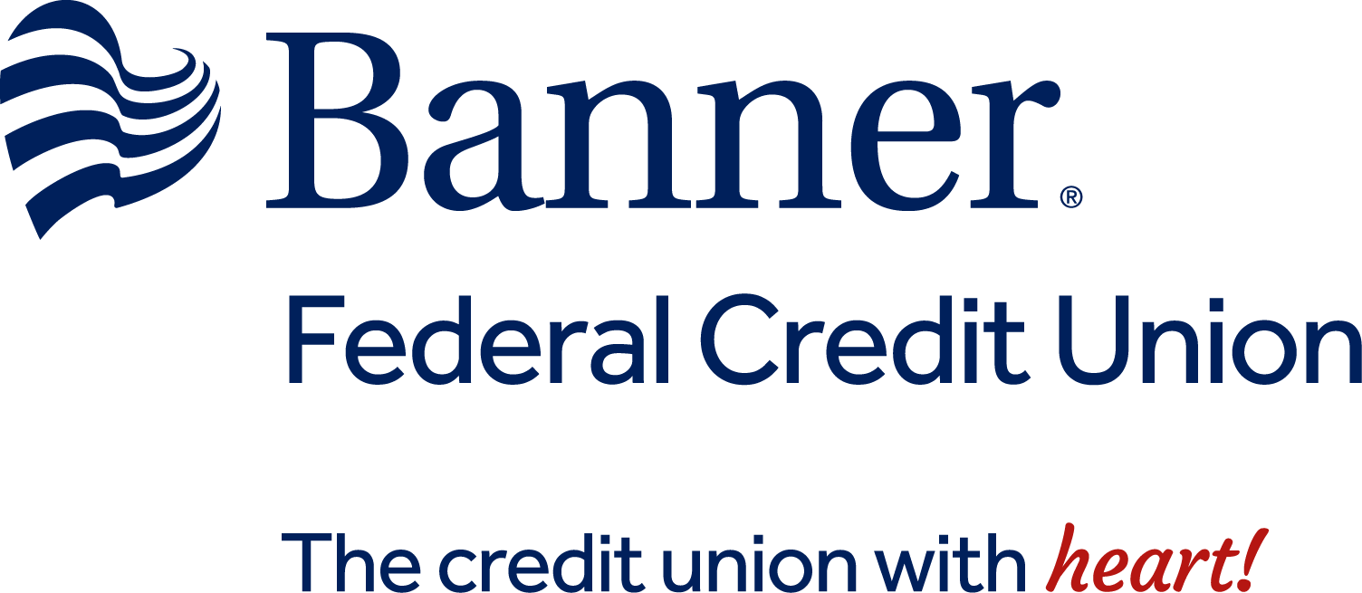

Banner Federal Credit Union

9321 W. Thomas Rd. Ste. 125

Phoenix AZ 85037

Phone: 602 254-5291 - 800 467-6633

Account Disclosure Rate Supplement

and Schedule of Fees and Charges

This supplement is incorporated into, becomes
a part of, and should be attached to Your Agreements and Disclosures.

The Annual Percentage Yields for each

Account Type is shown below:

Type | Effective Date:  April 1, 2023  Balance | Annual Percentage Yield* | Annual  Percentage  Rate*
Share 00 | $75.00 or greater | 0.05% | 0.05%
Checking 91 | $500.00 or greater | 0.01% | 0.01%
Holiday Club 63 | $75.00 or greater | 0.05% | 0.05%
Vacation 64 | $75.00 or greater | 0.05% | 0.05%
Miscellaneous Club 69 | $75.00 or greater | 0.05% | 0.05%
Money Maximizer 68 | Less than $1,000.00 | 0.50% | 0.50%
 | $1,000.00 - $9,999.99 | 0.75% | 0.75%
 | $10,000.00 - $24,999.99 | 0.80% | 0.80%
 | $25,000.00 or greater | 1.00% | 1.00%
IRA 61 & 62 | Less than $10,000.00 | 2.00% | 1.99%
 | $10,000.00 or greater | 2.05% | 2.04%

Current Share and IRA Certificate Rates *
Term | Balance | Annual Percentage Yield | Dividend  Rate | Share Certificates  Type Codes
6 Months | $500.00 - $9,999.00 | 0.00% | 0.00% | 01 50 62 74
 | $10,000.00 or greater | 0.00% | 0.00% | 02 51 63 75
1 Year | $500.00 - $9,999.00 | 1.93% | 1.91% | 03 52 64 76
 | $10,000.00 or greater | 1.98% | 1.96% | 04 53 65 77
18 Months | $500.00 - $9,999.00 | 2.00% | 1.98% | 05 54 66 78
 | $10,000.00 or greater | 2.05% | 2.03% | 06 55 67 79
2 Years | $500.00 - $9,999.00 | 2.03% | 2.01% | 07 56 68 80
 | $10,000.00 or greater | 2.09% | 2.07% | 08 57 69 81
30 Months | $500.00 - $9,999.00 | 2.09% | 2.07% | 09 58 70 82
 | $10,000.00 or greater | 2.14% | 2.12% | 10 59 71 83
3 Years | $500.00 - $9,999.00 | 2.14% | 2.12% | 11 60 72 84
 | $10,000.00 or greater | 2.19% | 2.17% | 12 61 73 85
* For the purposes of this disclosure, this is the APY that were offered within the most recent seven calendar days. The Dividend Rate(s) and Annual Percentage Yield(s) shown herein are current as of the effective date. For more current rates, please call 602 254-5291.

